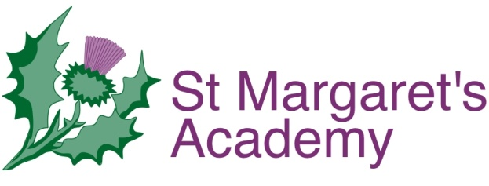
‘Learning today...to achieve our tomorrows’

Email: admin@st-margarets.torbay.sch.uk
Website: www.stmargaretstorbay.co.uk

St Margaret’s Academy

CLUBS NEWSLETTER
AUTUMN 2017

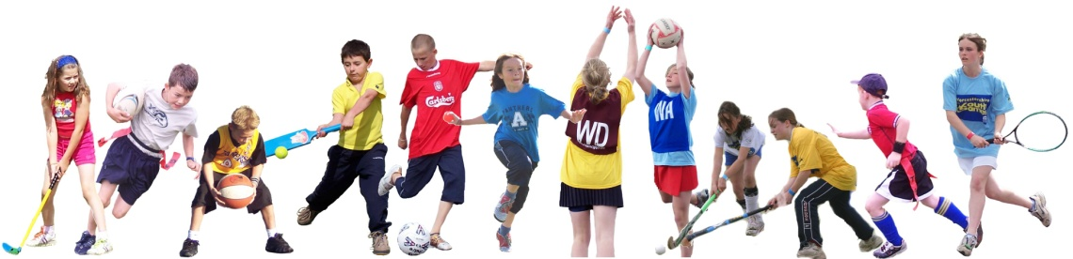

All clubs begin week commencing 18th September, ending on Thursday 14th December unless stated otherwise.

St Margaret’s Academy
We are pleased to be able to continue to offer a wide range of after school, lunchtime and early morning clubs this term. We are committed to providing a rich and exciting curriculum and we believe that our clubs have a role to play in enriching the curriculum. The school offers clubs that teach gymnastics, football, dance and even cooking, most of which are free. Not only are these clubs fun, but they will also help boost your child’s self-esteem and self-confidence.
How will it be organised?
This term, we will run clubs for a total of 11 weeks. The clubs will be run by teachers and outside agencies, such as Premier Sport. The children will go to the club as soon as the school day finishes and then can be collected at the finish time; usually 4pm unless stated otherwise on the clubs timetable. If you would like your child (Y5-Y6 only) to walk home from the club, you must inform the teacher running the club by letter.

Is there a cost?
Sometimes, in order to run such a wide range of clubs we have organised outside agencies to come into school to help run some clubs. The cost of these clubs will vary depending on the club being offered. Payment can be made online via the School Gateway.

How can my child get a place at a club?
Read the booklet and discuss which club or clubs your child would like to join. You will then need to go online and use the School Gateway to sign up to a club. We will strive to ensure that all children are placed in the club they desire. Places are limited; all are first come, first served, so please act quickly! ALL CLUBS BEGIN WEEK COMMENCING 18th September UNLESS STATED OTHERWISE ON THE TIMETABLE.

Non-attendance
If your child misses a club for two weeks in a row, unless there is a medical reason, they may be asked to leave the club and the space will be made available to another child. Why? Signing up to a club is a commitment and we would expect children to honour this. We believe that this is a life skill as well as an expectation. Some clubs lead on to competitions with other schools and children will need to commit to attending every session in order to build a team to enter leagues and competitions.

What next?
Read the booklet with your child and check which clubs are open to which year groups. Make a note of the days and times and then sign up via the School Gateway ASAP, THE DEADLINE FOR ALL CLUBS IS WEDNESDAY 13TH SEPTEMBER.
CLUBS TIMETABLE

Day | Clubs | Year | Location | Cost
Monday  3.05-4.15pm  3.05-4.05pm | Girls Football: Mr Mayling  Multi-skills: Premier Sport | Y5-Y6  Y1-Y2 | Field or B/Court  L/PG or Hall | FREE  FREE
Tuesday  Lunchtime  3.05-4.00pm  3.05-4.15pm | Loom Band Club: Mrs Turner  Quicksticks Club: Mr Mayling  Netball Club: Mrs Price & Mrs Broom | Y2-Y3  Y5-Y6  Y5-Y6 | Apple Class  Hall  L/PG or Hall | FREE  FREE  FREE
Wednesday  8.00-8.45am  12.30-1.00pm  3.05-3.45pm  3.05-4.15pm  3.05-4.05pm  3.05-4.30pm | Gymnastics Club: Premier Sport  Lego Club: Mr Rogers  Spanish Club: Mr Tullier  Alternative Sports Club: Premier Sport  Choir: Miss Pritchard  Let’s Get Cooking Club: Mrs Bundy & Miss Henley | Y5-Y6  Y3-Y4  Y3-Y6  Y3-Y4  Y3-Y6  Y5-Y6 | Hall  Holly Class  Rowan  Class  Hall or L/PG  Birch  Woodland Den | FREE  FREE  FREE  FREE  FREE  £6  (6 WKS)
Thursday  8.00-8.45am  3.05-4.00pm  3.05-4.05pm | Boys Football Club: Mr Robinson  Healthy 60: Mr Mayling  Football Club: Premier Sport  (boys and girls) | Y5-Y6  Y3-Y4  Y3-Y4 | Field  Hall or L/PG  Field or  Hall | FREE  FREE  FREE
Friday  8.30-8.45am  3.05-4.05pm | Golden Mile Running Club: Mr Tullier  Dance Club: Premier Sport | Y3-Y6  Y5-Y6 | Field, L/PG, Hall  Hall | FREE  FREE
If you are interested in any of the above clubs you will need to sign-up via the School Gateway. After you sign-up you will receive a text confirmation of the place and be notified that your child can attend.
Clubs Information
Y5-Y6 Girls Football Club: Mr Mayling
Girl’s football club will be run by PE Teacher Mr Mayling. Learn new skills and play as part of a team. Girls will need to commit to attending every session in order to build a team to enter the league. Girls selected from the weekly club will also need to be available to represent the school in matches.

Y1-Y2 Multi-skills: Premier Sport
Multi-skills will be run by a Sports Coach from Premier Sport. This club is a great way to develop their fundamental skills of agility, balance and co-ordination which are the key building blocks in a child’s physical development. Children will have the opportunity to be active in a safe environment and have fun at the same time. This club will lead into inter school competitions with other schools.

Y2-Y3 Loom Band Club: Mrs Turner
Come along and create bracelets/chains, anything with loom bands.

Y5-Y6 Quicksticks Club: Mr Mayling
Quicksticks is designed to introduce young people to the game of hockey. It is 4-a-side, can be played on any surface, and uses a larger, lighter and safer ball. It is a fun, fast, safe and exciting game that has been designed so that anyone can play the game, regardless of previous hockey experience. Hockey is a sport that can be used as an excellent tool to help develop well rounded young people. The sport is dynamic, teamwork is key and player’s respect for their opponents is at the heart of the game. This club will lead to inter school competitions with other schools in the area. I’m looking for hockey players in school that have a balance of talent, teamwork and sportsmanship to build a winning team!

Y5-Y6 Netball Club: Mrs Price & Mrs Broom
Netball club will be run by Mrs Price & Mrs Broom. All year 5 and 6 are welcome. Come along and learn High 5 Netball. All abilities are encouraged. Come along and enjoy a new sport and have the opportunity to represent the school in tournaments (priority to those who trained last term).

Y5-Y6 Gymnastics Club: Premier Sport
Gymnastics club is run by a Premier Sport Coach before school starts and is for children who love gymnastics or would like to improve their skills or explore new ones. Research has shown an exercise session in the morning before school will help get their heart pumping and can provide them with an energy boost which helps them with their concentration and attainment.

Y3-Y4 Lego Club: Mr Rogers
If you love Lego then you’ll love this club. Come along and use your imagination to create some cool Lego builds!

Y3-Y6 Spanish Club: Mr Tullier
Hola! Spanish Club is run by Mr Tullier; he spent three years learning the language whilst teaching in Spain. Mr Tullier does everything to make learning Spanish fun and build confidence and fluency easily and quickly. So come along and learn basic Spanish for free.

Y3-Y4 Alternative Sports Club: Premier Sport
The aim of the club is to increase participation, encourage healthy lifestyles and inspire all young people to benefit from the positive values of physical activity and sport. The children will take part in fun alternative activities such as: Archery, Kurling, Street Surfing, Fencing, Dodgeball, Frisbee and Golf with an emphasis on enjoyment and discovery and not competition.

Y5-Y6 Let’s Get Cooking Club: Mrs Bundy & Miss Henley
This term we have teamed up with Tesco to bring you a fantastic cooking club. The children will try new recipes and learn about nutrition and how to create a balanced diet etc. Places are limited and there is a very small charge to help pay for ingredients for the club (online payment via School Gateway once your child’s place has been confirmed).
Y5-Y6 Boys Football Club: Mr Robinson
Boy’s football club will be run by Y5 Teacher Mr Robinson. Learn new skills and play as part of a team. Boys will need to commit to attending every session in order to build a team to enter the league. Boys selected from the weekly club will also need to be available to represent the school in matches. This club will start on Thursday 14th September.

Y3-Y4 Healthy 60: Mr Mayling
Healthy 60 Sports Club is run by PE Teacher Mr Mayling. It is an exciting programme that aims to harness the inspiration of the Olympic and Paralympic Games. The club takes the principles and specific skills from a range of sports and place them in a fun, vibrant and exciting activity club giving children confidence and competence.

Y3-Y4 Football Club: Premier Sport
Football/multi-skills activity coaching club for boys and girls. Learn new skills and play as part of a team.

Y3-Y4 Golden Mile Breakfast Club: Mr Tullier
We reinforce the message from the Department of Health that children should engage in regular daily physical activity habits across the week, every week , all year round. The Golden Mile is an ALL YEAR ROUND initiative whereby Pupils, Staff and Parents can get involved. Simply walk, jog or run around our Golden Mile track within the safety of the school grounds and achieve some extra laps to add to your miles.
Y5-Y6 Dance Club: Premier Performing Arts
Dance is very popular amongst children, as it combines physical literacy and experimentation, creativity and it develops self-knowledge and social skills. We are developing Dance further in school and using the PE & Sport Premium to pay for a Dance specialist to deliver a Dance Club. This club will lead to a performance with other schools.

The School Gateway for clubs will open from Thursday 7th to Wednesday 13th September.

