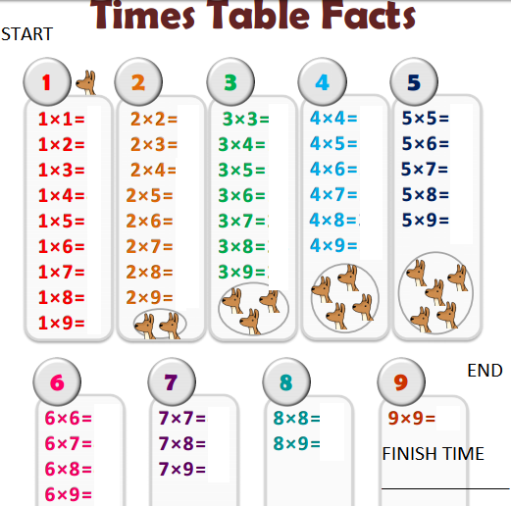

NAME: ______________________________________
TARGET TIME: __________________________

BRONZE : All correct in less than 5 minutes
SILVER: All correct in less than 3 minutes
GOLD: All correct in less than a minute and a half
PLATINUM: All correct but can you get the fastest time in the class?!

